Course 3 Tableau follow-along guide: Automatidata project

This document includes detailed instructions for how to perform the data visualizations described in the Course 3 end-of-course project.

Instruction | Example Screenshot
Go to https://public.tableau.com/s/  Log in to your account. | 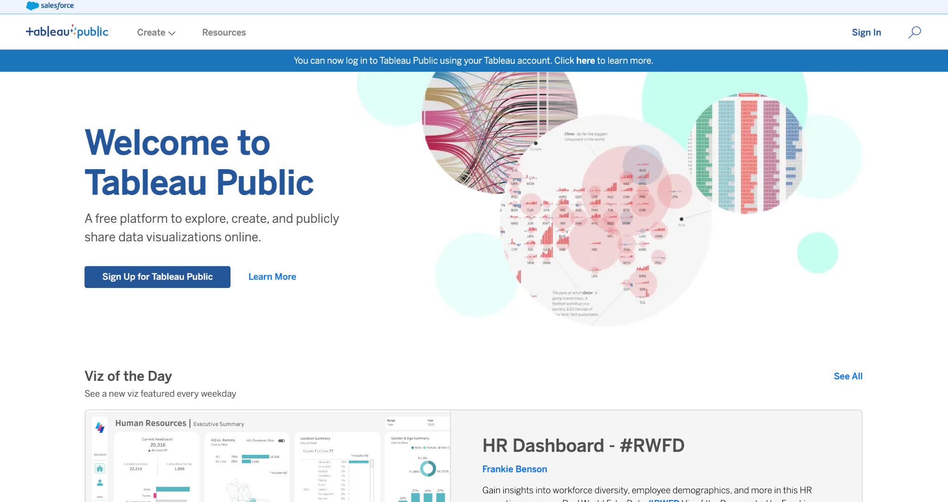
Go to “My Profile” at top right of Tab Public homepage. | 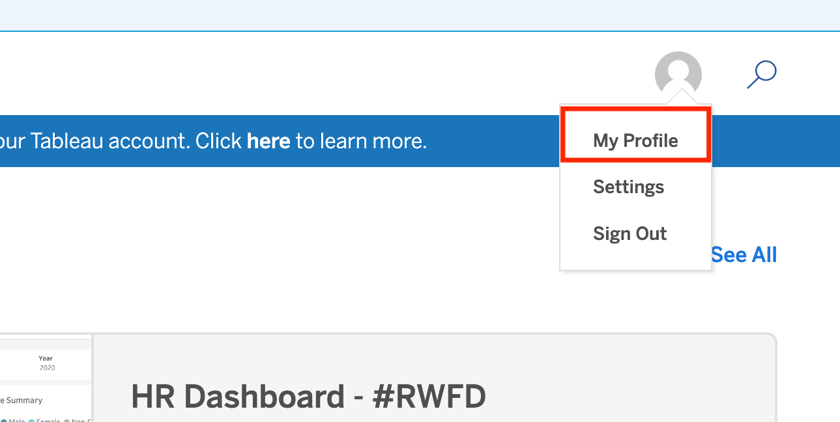
Under “Vizzes,” select “Create a Viz.” | 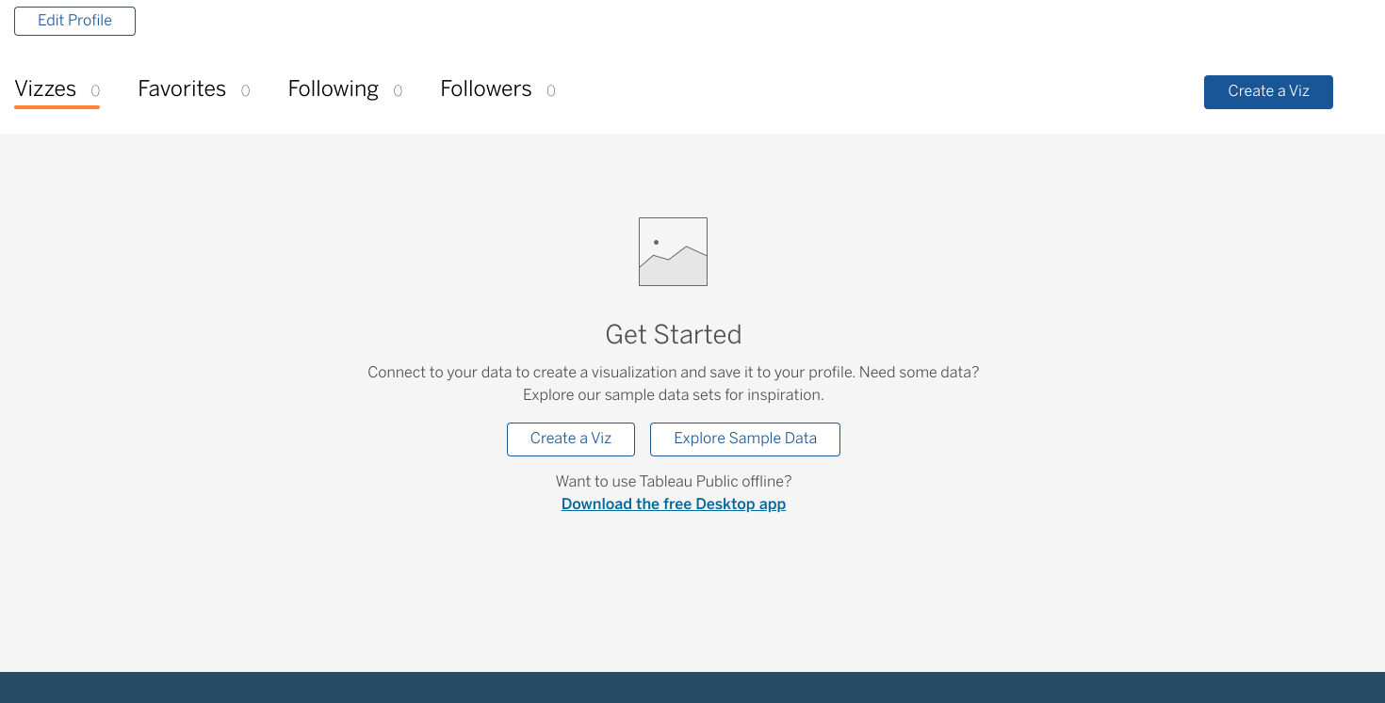
Upload the data provided by the New York City TLC. | Please click here to download the 2017 New York City TLC dataset. The dataset is accessible through Coursera. After downloading the dataset, come back to this page of instructions and continue with the next task in Tableau Public.
Click on NEW WORKSHEET.  Note: Please allow for several minutes for data import into a new worksheet | 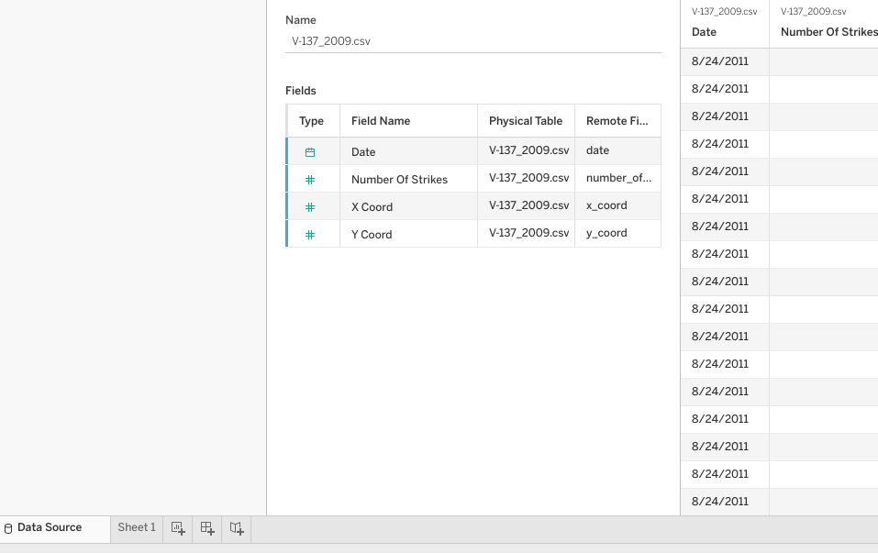
- Drag ‘Total Amount’ to Columns shelf  - Drag ‘Trip Distance’ to Rows shelf  Note: Be sure to convert both variables from “Measure” to “Dimension.” | 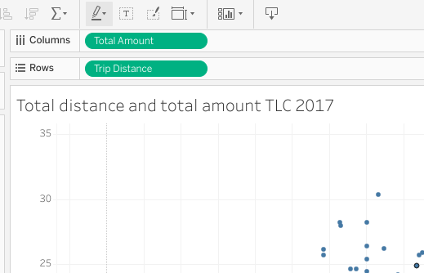
- Create Calculation with the “Trip Distance” variable by clicking on the “Trip Distance” dropdown and selecting “Create Calculated Field …”  - Write calculation as “[Trip Distance]=0”  Note: Ensure ‘Trip Distance” is converted to dimension before creating a calculated field. | 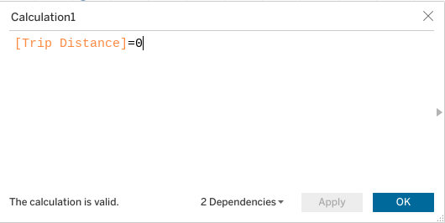
- Drag your new calculation variable to the “Colors” box. | 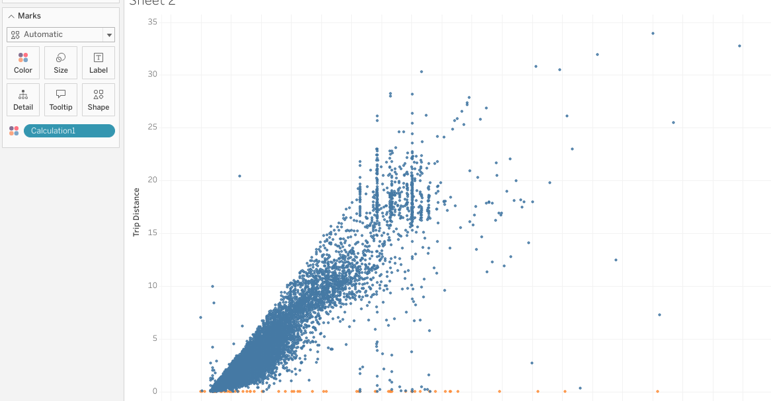
- Set viz title and an annotation for clarity | 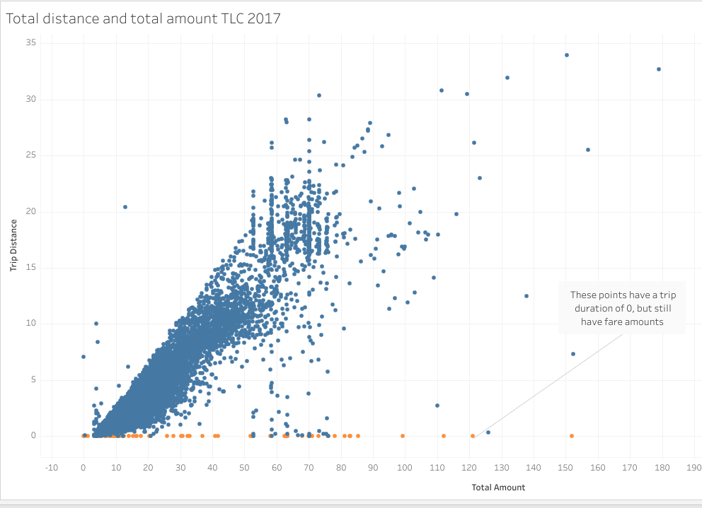
Take a screenshot of your visualization and plug it into your executive summary! | N/A

